

SMART INDIA HACKATHON 2026

3D ULPIN GENERATOR

- Problem Statement ID– SIH26011

- Problem Statement Title- 3D ULPIN Generation

and Vertical Property Mapping System

- Theme- Smart Automation

- PS Category- Software

- Team ID- PIET-256

- Team Name- Spark-X

Spark-X

Core Problem
  - Conventional land records in
India are primarily 2D and
identify surface-level parcels.

    - 2D records cannot clearly represent vertically separated property units in multi-storey
buildings.

3D ULPIN GENERATOR

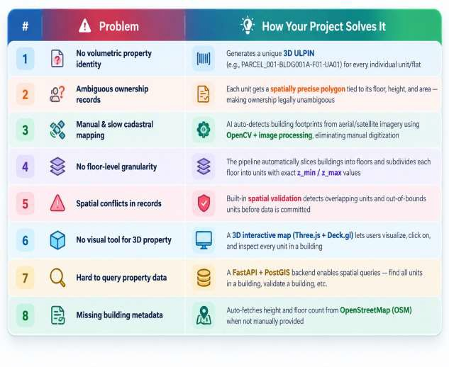
Parcel Id for this Building will be same for all same even thought it can be owned by different individuals







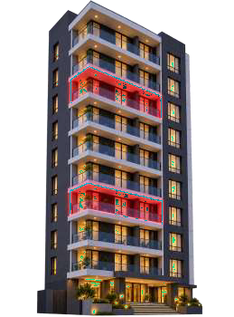



  - Multiple floors/units may lie above the same land parcel, making floor- and unit-level
spatial identification difficult in a
purely 2D cadastral system.

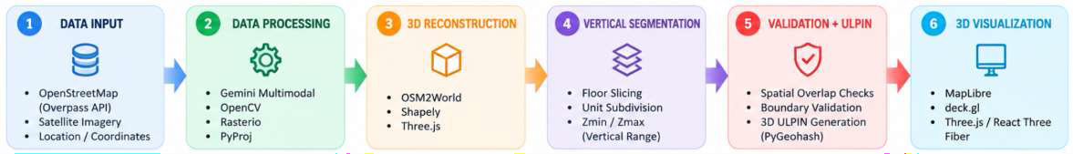
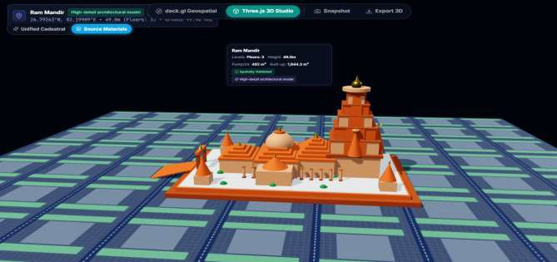
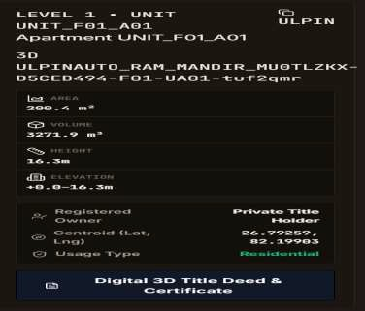
TECHNICAL APPROACH

Spark-X

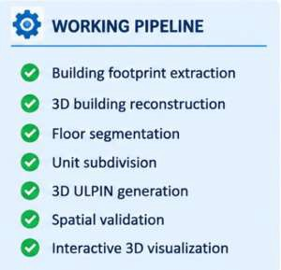

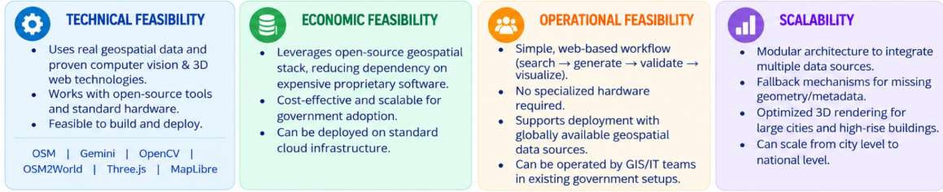
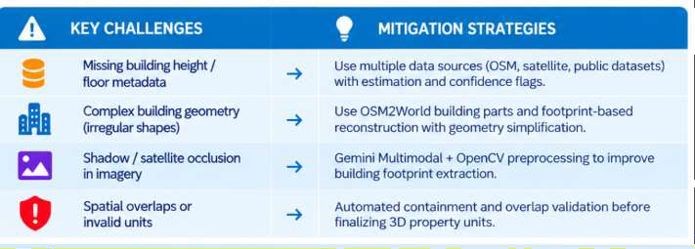
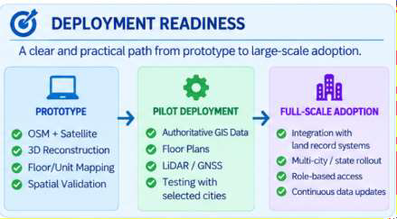
FEASIBILITY AND VIABILITY

Spark-X

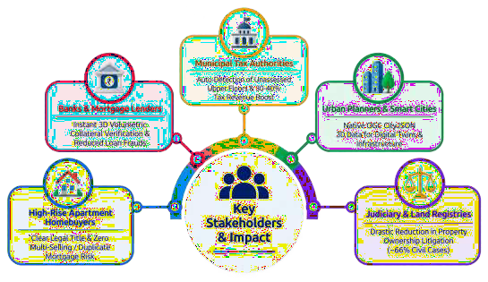

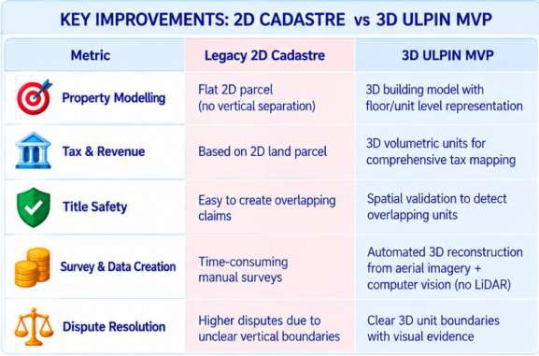
Spark-X

IMPACT AND BENEFITS

Spark-X

RESEARCH AND REFERENCES

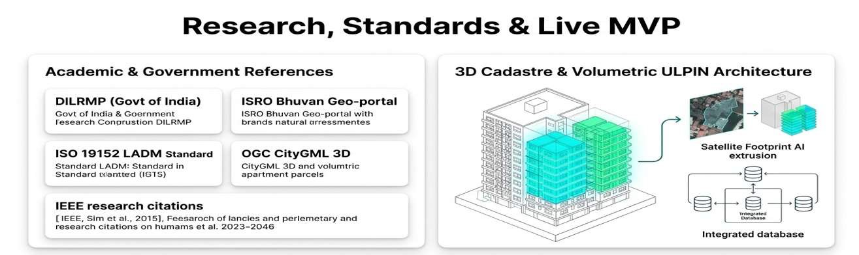

Live Prototype & MVP

https://3-d-ulpin-mvp.vercel.app/
Official Portal Tags
https://bhuvan.nrsc.gov.in/

